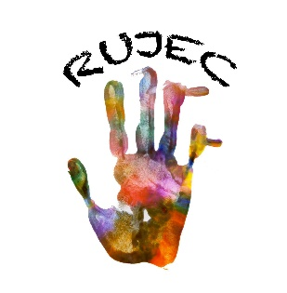 | A creative, values-based program preparing children for the future  Rosie Uran Jewish Education Center  Congregation Sha’are Shalom  19357 Evergreen Mills Road, Leesburg, VA 20175  703.737.0686 • rujec@shaare-shalom.org  Allison Musa & Sheryl Brotman, Co-Directors
APPLICATION FORM 2023-24

Child’s Full Name_______________________________________________________________________

Name to be called at school__________________________________

Birth Date________/________/________ Gender: M______ F______

Child's Address________________________________________________________________________

Child's Home Phone_______________

Parent/Guardian Preferred Cell Phone_______________ Preferred Email___________________________

Parent/Guardian #1 Name_________________________________________________________________

Cell Phone_________________________ Email___________________________

Address & Home Phone if different from child’s _____________________________________________

_________________________________________________________________________________

Parent/Guardian #2 Name________________________________________________________________

Cell Phone_________________________ Email___________________________

Address & Home Phone if different from child’s _____________________________________________

_________________________________________________________________________________

Indicate which class:
( ) 3-Day 2’s (W-TR-F) 9-12, no lunch Must be 2 years old on or before September 30, 2023
( ) 3-Day 2’s (W-TR-F) 9-1 Must be 2 years old on or before September 30, 2023
( ) 4-Day 3’s (T-F) 9-1 Must be 3 years old on or before September 30, 2023
( ) 4-Day 4’s (T-F) 9-1 Must be 4 years old on or before September 30, 2023

Congregation Sha’are Shalom member? Yes__ No__ Affiliated with another synagogue? Yes__ No__

PAYMENT INFORMATION
Enclose $150.00 Registration Fee per child with this application. This fee is non-refundable unless the school is unable to enroll your child by September 2023.
Please make checks payable to: Congregation Sha'are Shalom
Mail applications and checks to: CSS - RUJEC, PO Box 4518, Leesburg, VA 20177

